**FINANCIAL MANAGEMENT DOCUMENT**

1. ***APPLICATION CONCEPT:***

*-* ***Finamana*** *is a* ***mobile*** *application, which help user to manage his Finance.*

*- Whenever user pay or earn money, a* ***transaction/record*** *is created. The app allows User to record that transaction into its database* ***manually****.*

*- The app manages user’s* ***Records*** *month by month. Every month of a year has only 1* ***Table****, and a Table consists of many* ***Records*** *of that month. This feature of Tables and Records is called* ***Financial Management****.*

*- The application also provide some feature for user to have an overall look at their transactions, which are* ***Financial Report*** *and* ***Statistics****.*

1. ***APPLICATION STRUCTURE:***

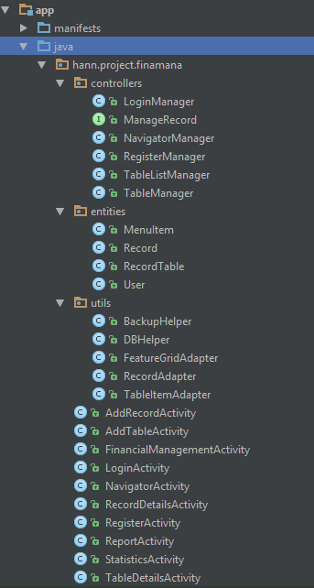- Finamana is built on the MVC Design Pattern Structure.

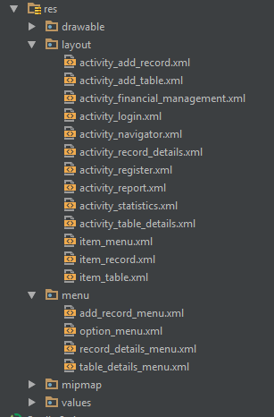

*-* ***Model****: Take responsibility for forming the data model. All the models classes are included in the package* ***hann.project.finamana.entities.***

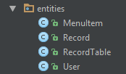

*-****View****: is responsible for presentation all the needed data. They are xml files, which are included in the* ***res/layout*** *directory. Every activity has its own java class to interact with models and controllers, which are located in package* ***hann.project.finamana****.*

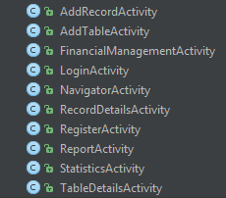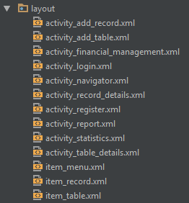

*-****Controller****: Are those classes, which handle the business logic and algorithms. They are located in the package* ***hann.project.finamana.controllers.*** *And there are some class help supporting controllers, they are in* ***hann.project.finamana.utils.***

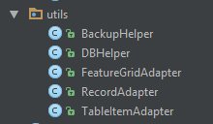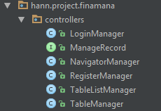

1. ***APPLICATION FEATURES:***

***3.1-Login and Register:***

- The app requires user to **SIGN IN** to use its features. If user does not have account, he can get one by feature **SIGN UP**.

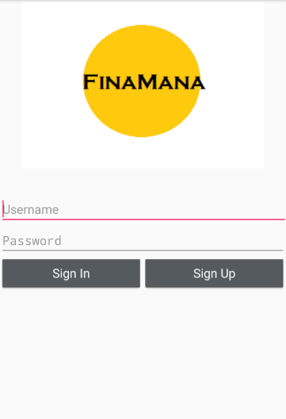

- Click **Sign Up** will get user to the Register page.

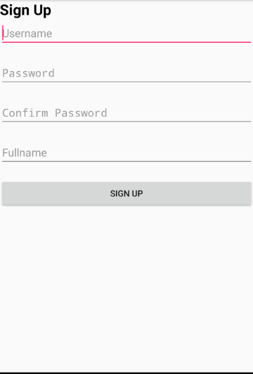Requirement:

- **username** length: 6 ~ 16 characters.

- **password** length: 6 ~ 16 characters.

- **confirm password** must match **password**.

- **Fullname** length under 30 characters, can be null.

- **username** must not be existed.

*Register Unit test:*

1. **Test Sign up with all blank fields.**

-Parameters: Leave all the fields not inputted.

-Action: Click **Sign Up.**

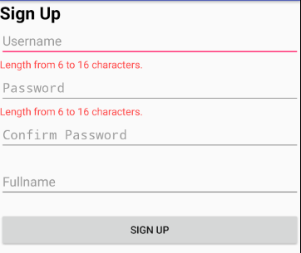-Expected:

-Actual: Passed.

1. **Test Sign up with username and input length < 6.**

-Parameter:

Username: hann

Password: qwer

-Action: Click **Sign Up**.

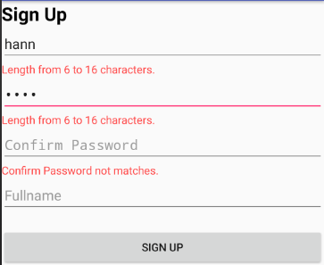 -Expected:

-Actual: Passed.

1. **Test Sign up with not match confirm password.**

-Parameter:

Username: hann12

Password: qwerty

Confirm password: qwerty

-Action: click **Sign up**

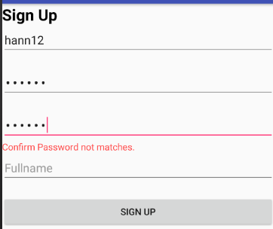-Expected:

-Actual: Passed.

1. **Test Sign up correctly.**

-Parameter:

Username: hann12

Password: qwerty

Confirm: qwerty

-Action: click **Sign up**

**-**Expected:

Popup: Register Successfully.

Redirect to login page.

-Actual: Passed.

1. **Test Sign up with duplicated user.**

-Parameter:

Username: hann12

Password: qwerty

Confirm: qwerty

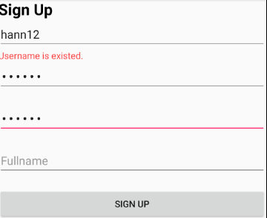-Expected:

-Actual: Passed.

1. **Test Sign up with wrong fullname.**

-Parameter:

Username: hann13

Password: qwerty

Confirm: qwerty

Fullname: London bridge is falling down, falling down, falling down.

-Action: Click **Sign up**

-Expected: 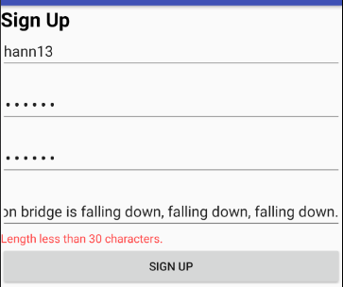

-Actual: Passed.

*Login Unit test:*

1. **Test Login with wrong username and password.**

Parameters:

Username: (blank)

Password: (blank)

Username: hann12

Password: qqqqqq

-Action: Click **Sign In** button.

-Expected: Pop up “Incorrect username or password”

-Actual: Passed.

1. **Test Login with registered username and password.**

Parameters:

Username: hann12

Password: qwerty

-Action: Click **Sign In** button.

-Expected:

Popup: “LOGIN SUCCESS”

Redirect to **Navigator Screen**.

-Actual: Passed.

***3.2-Navigator Activity:***

- This activity provide user a menu of features that user can interact with.

**+ Financial Management:** Redirect user to Financial Management Activity. Allow user to create Tables and add Records to them.

**+ Financial Report:** Redirect user to Financial Report Activity.Provide user a financial report in current month and all months ever recorded.

**+ Statistics:** Redirect user to Statistics Activity. Show to user statistical data that can help them have a better financial decision in future.

**+ Setting:** Future feature.

**+ Backup data:** Back up the database file to SD card.

**+ Import data:** Import data from back up file.

**+ Logout:** Log user out of the app.

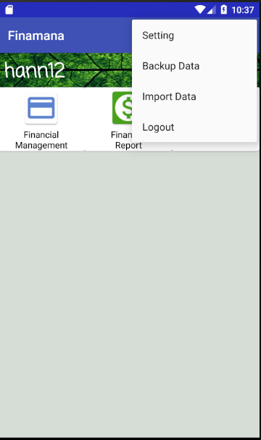- On the left top is user fullname. If fullname is not provided by user, username take that place instead.

***3.3-Financial Management Activity:***

-This activity shows a list of created Table to user. If no table have been created yet, the screen should show empty.

- Newer Table should be placed on top down.

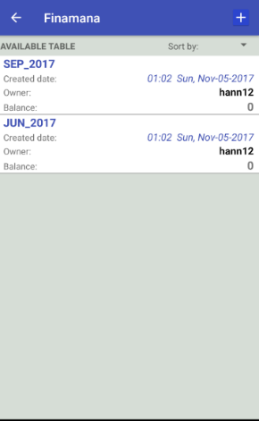 

- Features:

+Sort tables: Future feature.

+ **Create a new table**: by clicking on the button  located on the top right of the screen. It allow user to create new table of a specific month.

+ **See Table Details**: by clicking on a Table, User can see all the details of the Table.

+ **Back**: back to the **Navigator Activity**.

- A item in table list:

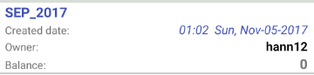

+Table name: is placed on top left.

***3.3.1-Create a new Table:***

-Create a table of a specific month.

-User only need to choose the year and the month of that year.

-Requirement: Every month of a year has its own Table.

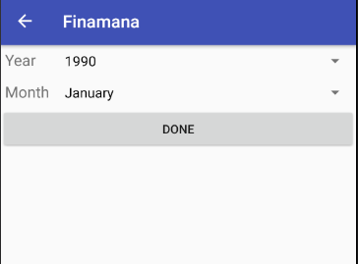

*Create new Table Unit Test:*

1. ***Test Create a new Table****.*

*-Parameters:*

*Year: 2017*

*Month: November*

*-Action: Click button* ***Done***

*-Expected:*

*Popup: “A table has successfully added”.*

*Redirect to Financial Management Activity*

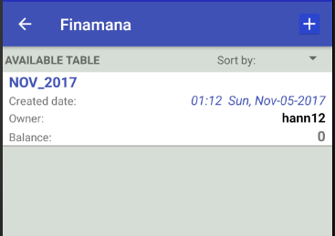

*-Actual: Passed.*

1. ***Test Create existed table.***

*-Requirement: Create a November 2017 Table first.*

*-Parameters:*

*Year: 2017*

*Month: November*

*-Action: Click button* ***Done***

*-Expected:*

*Popup: “Table existed, failed to create.”*

*Table list remains 1 item.*

*-Actual: Passed.*

1. ***Test button Back.***

*-Action: Click button* ***Back****.*

*-Expected: Redirect to* ***Navigator Activity****.*

*-Actual: Passed.*

***3.3.2-See Table Details:***

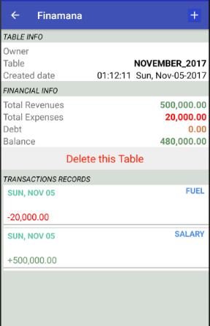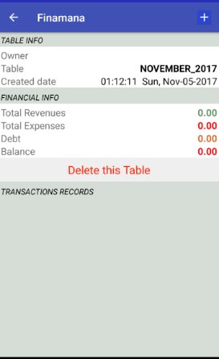 *-See the details the selected Table.*

*Requirements:*

*+ Fullname is displayed as Owner.*

*+ Table is the combined of Month and Year.*

*+ Created date is recorded when user create the Table.*

*+ Revenues a.k.a Income: The money user earn.*

*+ Expenses a.k.a Outcome: The money user pay.*

*+ Balance = Revenues – Expenses*

*+ If Debt increase, Revenues increase.*

*+ When Debt is paid, Debt decrease and Expenses increase by the same amount.*

*+ If no record is added, Transactions records remain empty.*

*+ Newer record is placed on top-down perspective.*

*-A record:*

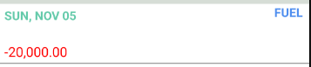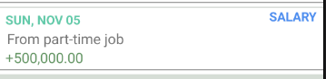

*+ Record Date is placed on top left.*

*+ Category of the transaction is placed on top right.*

*+ Below Record Date is Description (can be empty).*

*+ Money Amount:*

*If Revenues: green color with (+)*

*If Expenses: red color with(-)*

*Because* ***DEBT*** *increase Revenues, so it is considered as an* ***earn category****.*

***DEBT_PAY*** *increase Expenses, so it is a* ***pay category.***

*-Features:*

*+ Add a new Record: by clicking**, Allow user to add a new record to the Table.*

*+ A Dialog appears to make sure that user does not click this button by mistake. By choosing* ***OK****, user allow the app to delete this Table and all the related Records. Choose* ***CANCEL****, to stop the delete activity.*

*+See the Record Details: by clicking on an record, Allow User to Edit the record.*